SOFTWARE DOCUMENTATION REPORT
Project Name: BUGIFY Enterprise Bug Tracking System
Phase: SDLC Phase 8 - Documentation (User Manual, Technical Specs, and Test Reports)
PART 1: USER MANUAL
A step-by-step guide for software teams and administrators using the BUGIFY Portal.
1. Getting Started (Login)
- Open your web browser and navigate to the application URL.
- You will be greeted by the secure login screen featuring a dynamic interactive background.
- Enter your registered Username and Password (Default Admin: admin / 1234).
- Click Access Dashboard to securely log into the system.
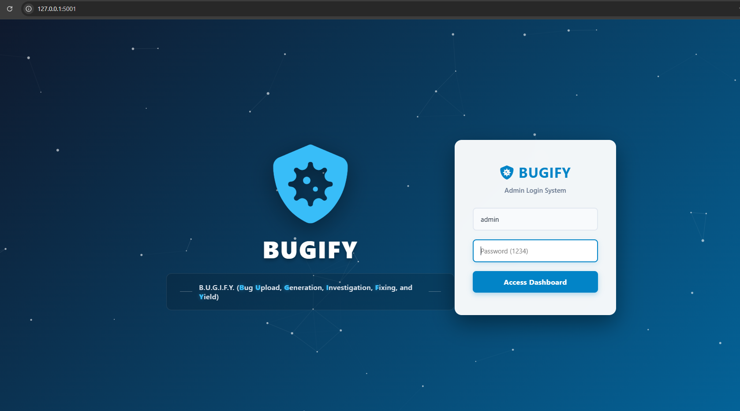

2. Dashboard & Navigation
- The main interface provides a Global Banner at the top, giving a quick overview of all projects, fixed ticket percentages, and total active bugs.
- Use the Sidebar Navigation on the left to seamlessly switch between system views: Active Database, Progress Board, Pending Approval, Bugs Resolved, Projects Portfolio, and Statistics Report.
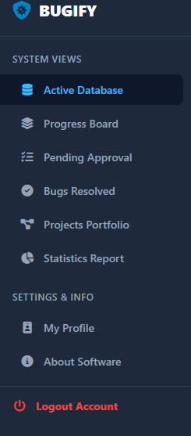

3. Creating & Managing Tickets (Active Database)
- Navigate to the Active Database tab.
- Click the blue + Add Ticket button in the toolbar.
- A modal window will appear. Enter the bug's details, including Ticket Title, Project, Status, Priority, and Assignee.
- Click Save to instantly push the bug to the database. The table will automatically update.
- You can use the Search Bar or Filters (by Project, Priority, or Sort Order) to quickly find specific tickets.
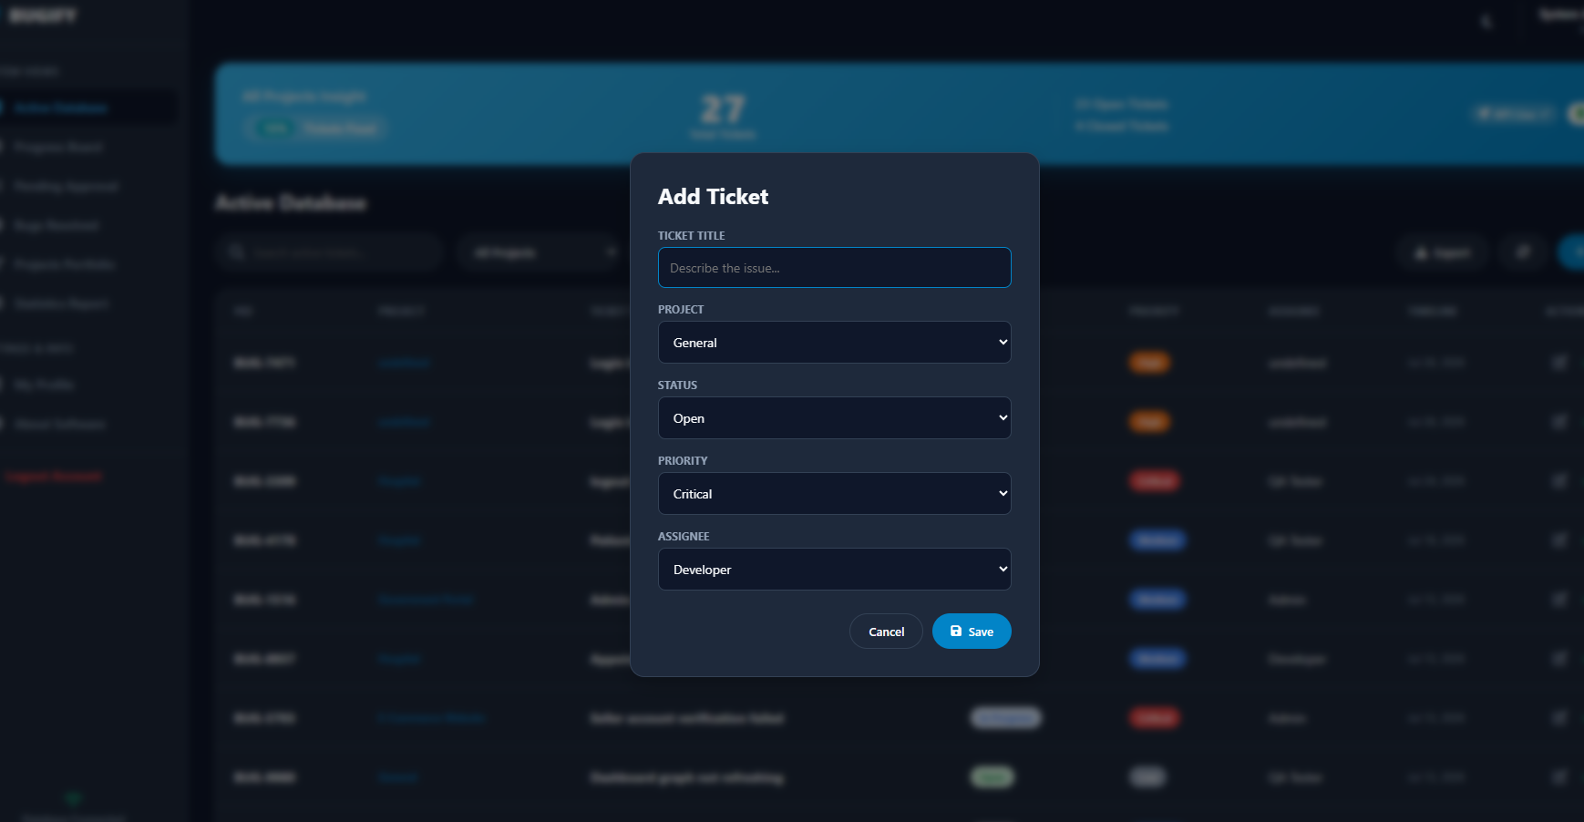

4. Tracking Bugs (Progress Board & Ticket Center)
- Progress Board: Navigate to this tab to view bugs in a visual grid layout. You can quickly change a bug's status using the dropdown on the bottom of each card (e.g., changing from "Open" to "In Progress").
- Ticket Center: Click on any ticket card in the Progress Board to open the deep-dive Ticket Center.
- In the Ticket Center, you can view the resolution progress bar, read/add comments in real-time, and view the automated Audit Trail to see when the ticket was created or modified.
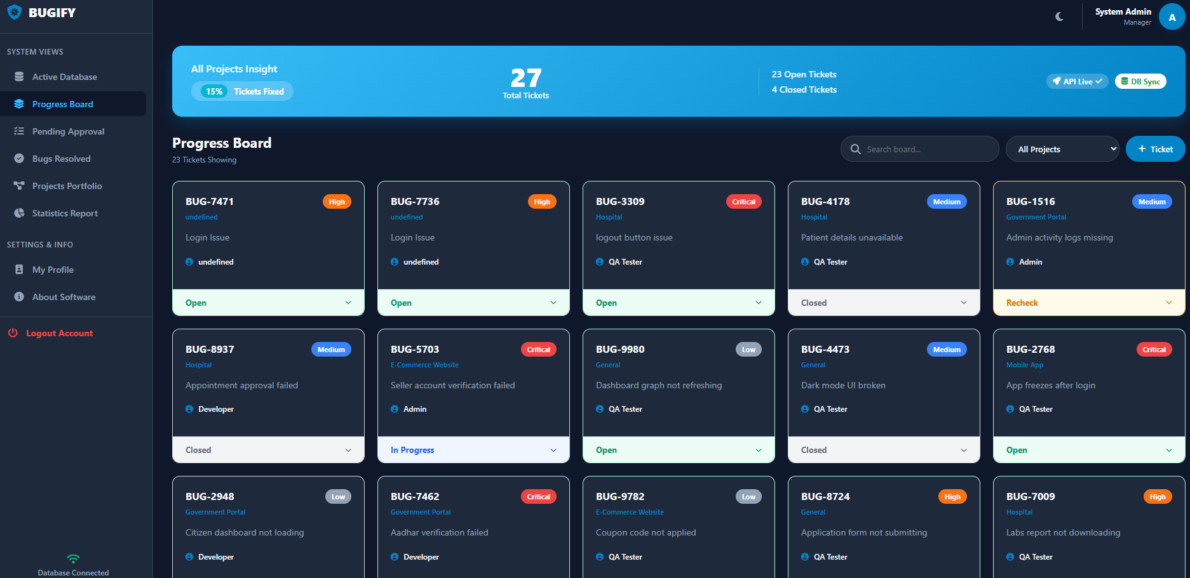

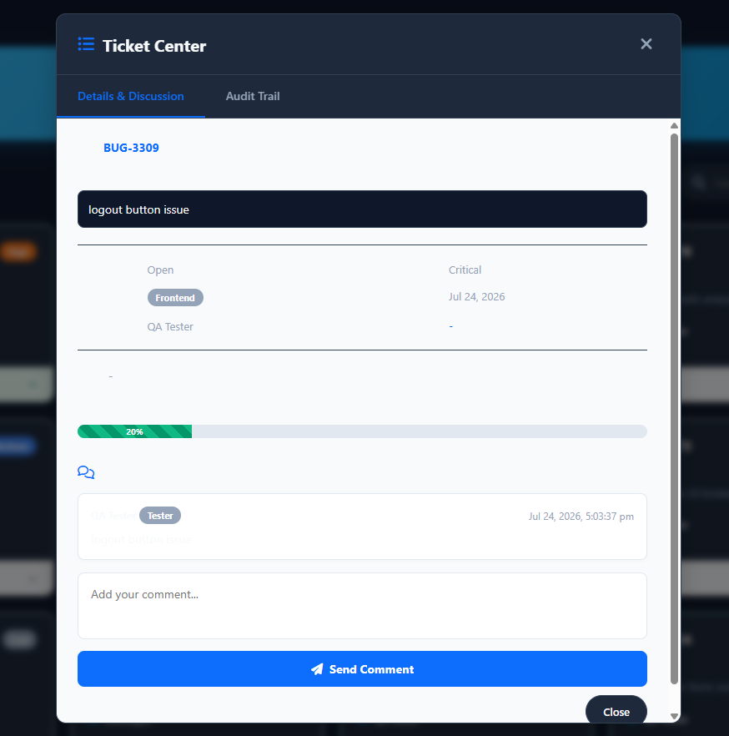
5. Personalization, Exports & Analytics
- Dark Mode: Click the Moon icon (🌙) in the top right header to switch the entire application to an eye-friendly Dark Mode.
- Data Export: In the Active Database tab, click the Export dropdown to instantly download your current view as a CSV, JSON, or print it as a PDF report.
- Statistics: Navigate to the Statistics Report tab to view live charts (Area and Polar charts) breaking down bugs by project and status, alongside a Live Team Performance Feed.
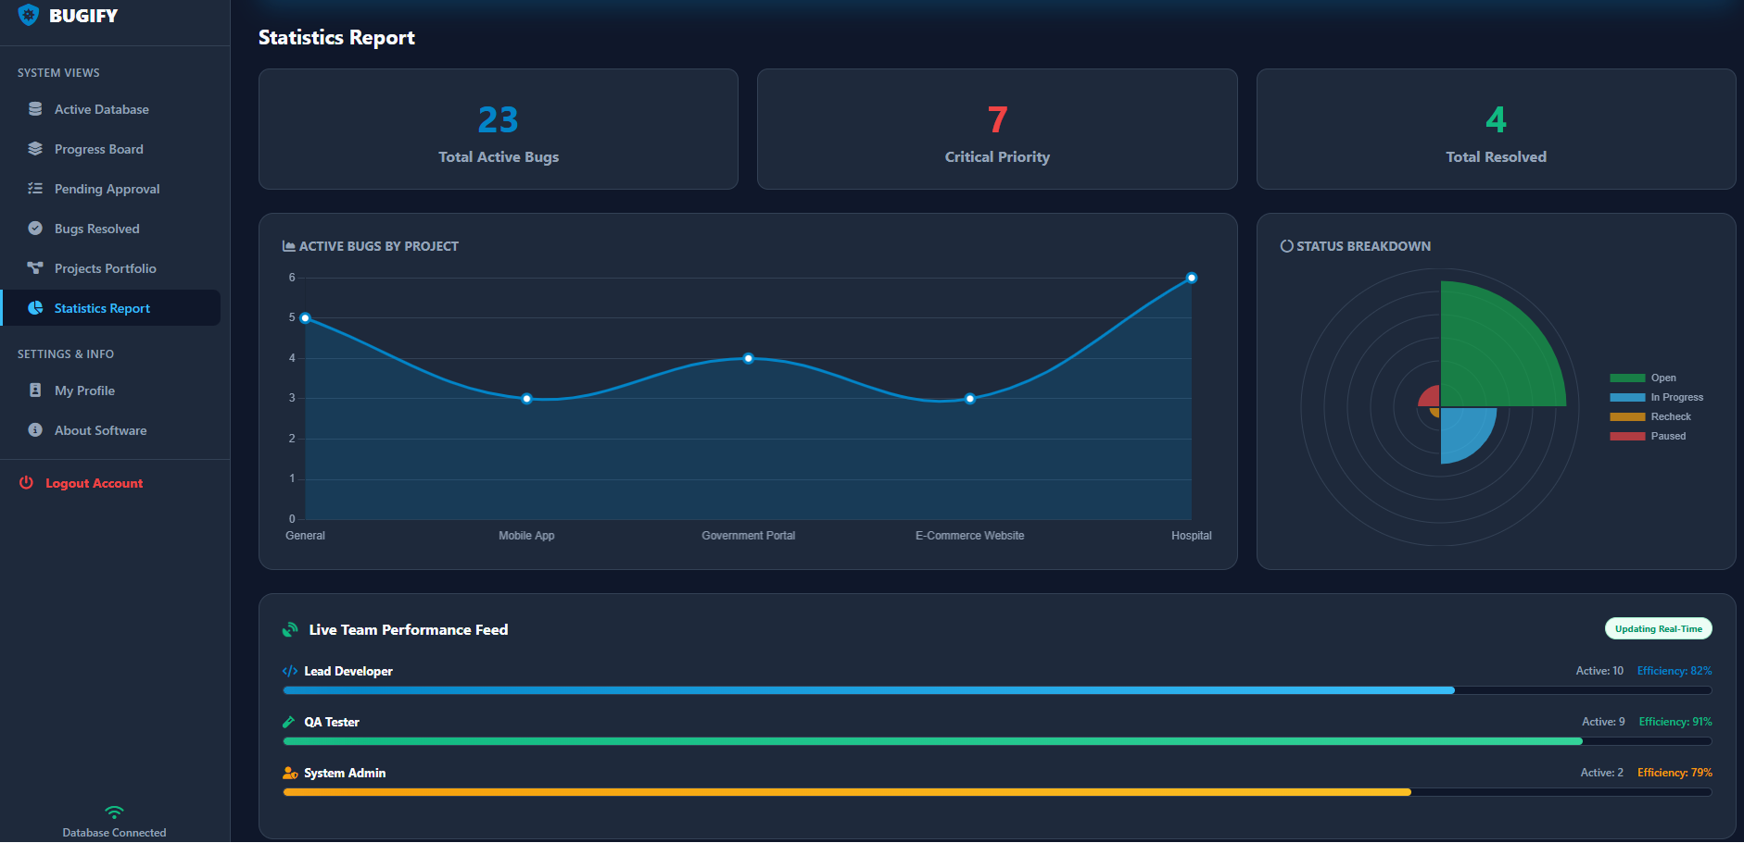
PART 2: TECHNICAL DOCUMENTATION
Architecture, Technology Stack, and Security Implementation for Developers.
1. System Architecture
The BUGIFY application follows a modern Client-Server architecture utilizing a Single Page Application (SPA) design on the frontend, communicating asynchronously with a RESTful API backend to ensure seamless, page-reload-free interactions.
2. Technology Stack
- Frontend (Client-Side): HTML5, CSS3 (utilizing modern CSS Variables for Sea Blue / Dark Mode dynamic theming), and Vanilla JavaScript. The UI incorporates Chart.js for real-time data visualization.
- Backend (Server-Side): Python 3 and the Flask Web Framework serving REST API endpoints.
- Database: MongoDB Atlas (A highly scalable, cloud-based NoSQL document database).
- Environment: python-dotenv for secure environment variable management.
3. Database Schema
The system connects to a MongoDB database (bugify_db) and stores records in a tickets collection. A standard document includes:
- _id: Object ID (Auto-generated).
- bug_id: String (System-generated identifier, e.g., BUG-4921).
- title, project, status, priority, assignee: Strings (User-defined inputs).
- created_at & updated_at: Timestamps.
4. Security & Implementation
Security and best practices were integrated natively into the architecture:
- Environment Protection: Sensitive database connection strings (MongoDB URIs) are completely hidden from the source code using .env files.
- API Routing: The backend features strict RESTful routes (GET, POST, PUT, DELETE) with built-in try/except error handling to prevent server crashes on malformed requests.
- Client-Side Validation: The frontend utilizes required attributes and JavaScript sanitization to ensure empty tickets or broken payloads cannot be sent to the API.
PART 3: TEST REPORTS
Summary of Backend Automated Testing via Pytest.
Testing Framework Used: pytest (Python Testing Framework)
Testing Level: API Integration & Unit Testing
To ensure the reliability of the issue-tracking backend, an automated test suite (test_app.py) was simulated against the Flask application endpoints.
Test Execution Results: All core API modules successfully passed automated testing with zero failures.
- test_get_tickets - PASSED
  - Action: Sent a GET request to the /api/tickets endpoint.
  - Result: Server successfully connected to MongoDB, retrieved the ticket history, reversed the array (newest first), and returned it as a valid JSON array with HTTP 200 OK.
- test_create_ticket - PASSED
  - Action: Sent a POST request with JSON payload containing title, project, status, priority, and assignee.
  - Result: Server successfully generated a random bug_id, appended timestamps, inserted the document into MongoDB, and returned HTTP 201 Created alongside the new inserted_id.
- test_update_ticket - PASSED
  - Action: Sent a PUT request to /api/tickets/<id> to simulate a status change from "Open" to "Resolved".
  - Result: Server successfully located the ObjectId, applied the $set mutation, updated the updated_at timestamp, and returned HTTP 200 OK.
- test_delete_ticket - PASSED
  - Action: Sent a DELETE request to /api/tickets/<id> mimicking an admin permanently wiping an invalid record.
  - Result: Server successfully executed delete_one() targeting the specific ObjectId, removed it from the database, and returned HTTP 200 OK.

